Description: Description: cid:RBUQUNFTOZLJ.IMAGE_26.bmp **2021 Fatalities - Permian Basin as of March 31, 2021 (2020 vs. 2021 YTD)**

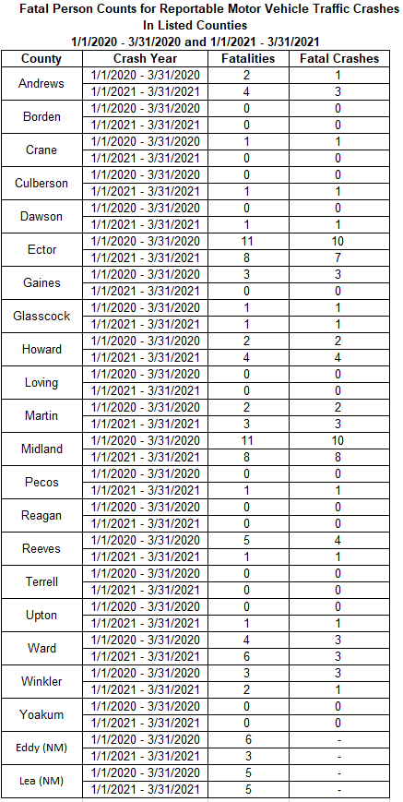

**Permian Area Counties (22 includes two New Mexico Counties)**

* **2020 – 56 Fatalities**
* **2021 – 49 Fatalities**

**Midland / Odessa Area**

* **2020 – 22 Fatalities**
* **2021 – 16 Fatalities**

**TXDOT Odessa District**

* **2020 – 39 Fatalities**
* **2021 – 34 Fatalities**

**Texas Statewide**

* **2020 – 855 Fatalities**
* **2021 – 936 Fatalities**